# UML Design Document

**System Name:** Project X  
**Date:** May 18, 2025  
**Prepared by:** ABE

## 1. Overview

This document describes the structure of the **University Course and Attendance Management System** using UML diagrams. The system facilitates dashboard-based user interactions for different roles (Admin, Lecturer, Student) and includes course management, attendance tracking, and login logging.

## UML Diagramsuml1

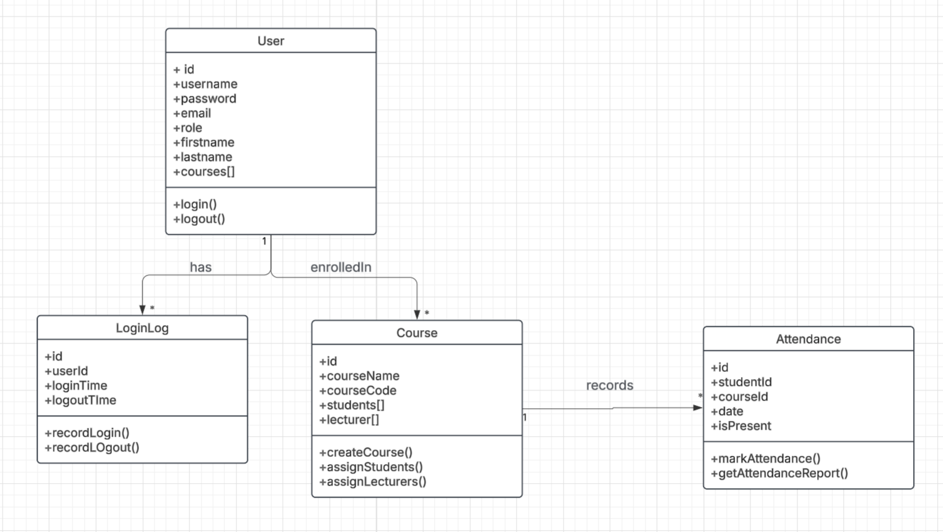

### 2.1 Interface and Class Implementation Diagram

This section represents how the Dashboard interface is implemented by three distinct dashboard classes.

#### Interface: Dashboard

**Methods:**

+viewDashboard()

+generateReports()

#### Classes Implementing Dashboard:

##### 1. AdminDashboard

**Methods:**

+manageUsers()

+manageCourse()

+generateReports()

+assignStudents()

##### 2. LecturerDashboard

**Methods:**

+viewCourse()

+markAttendance()

+generateQRCode()

+viewAttendance()

##### 3. StudentDashboard

**Methods:**

+manageUsers()

+manageCourse()

+generateReports()

+assignStudents()

### 2.2 Class and Relationship Diagram

This diagram defines the core entities of the system and their relationships.

#### Class: User

**Attributes:**

+id

+username

+password

+email

+role

+firstname

+lastname

+courses[]

**Methods**

+login()

+logout()

**Relationships:**

One-to-many with LoginLog

Many-to-many with Course (via enrolledIn)

#### Class: LoginLog

**Attributes:**

+id

+userId

+loginTime

+logoutTime

**Methods:**

+recordLogin()

+recordLogout()

**Relationship:**

Belongs to User

#### Class: Course

**Attributes:**

+id

+courseName

+courseCode

+students[]

+lecturer[]

**Methods:**

+createCourse()

+assignStudents()

+assignLecturers()

**Relationship:**

Many-to-many with User

One-to-many with Attendance

#### Class: Attendance

**Attributes:**

+id

+studentId

+courseId

+date

+isPresent

**Methods:**

+markAttendance()

+getAttendanceReport()

**Relationship:**

Belongs to Course